~Asia-China-Mirror- Warring States (475-221 BCE)-Lunar Lodges 28-Hexagrams 8- 12 zodical animals-animals of 4 directions

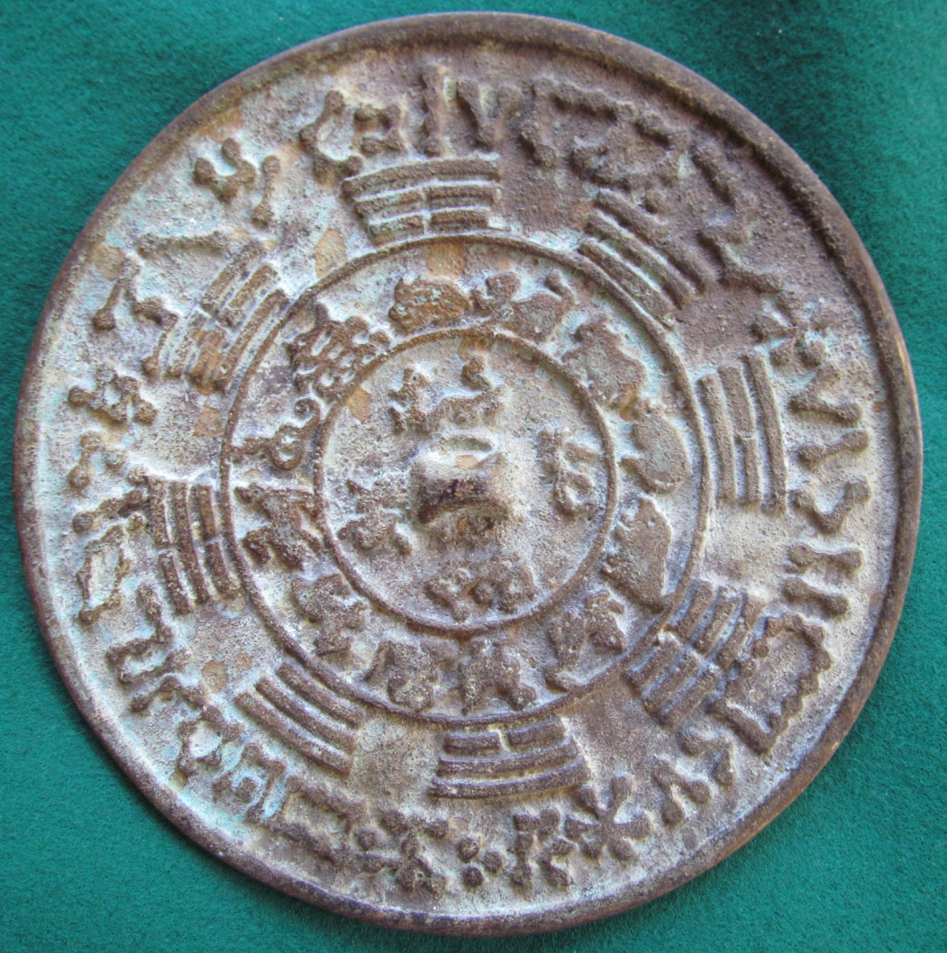

This unusual mirror is a concordance of the 28 lunar lodges, the 8 hexagrams, the 12 zodiacal animals and the animals of the 4 directions.